HTML5 - Day 1 - Hands On - R Veera Brahmanandam
Problem 1:
Problem Statement: Assessment Goal: Check if learners understand basic HTML structure and content creation.
Hands-on Tasks:
Create a basic HTML page with proper structure (DOCTYPE, head, body), Add a heading and a paragraph introducing yourself, create an unordered list showing your hobbies, create an ordered list showing daily routine steps, create a simple table showing: Student Name, Subject, Marks
Expected Outcome:
A static HTML page that displays structured content correctly in the browser.
Complete Source Code:
<!DOCTYPE html>
<html lang="en">
<head>
<title>Creating a Basic HTML Page</title>
</head>
<body>
<h1>Basic HTML Page</h1>
<p>Hello, I am Ryali Veera Brahmanandam from Rajahmundry, Andhra Pradesh </p>
<h3>My Hobbies Are</h3>
<ul>
<li>Playing Cricket</li>
<li>Sketching</li>
<li>Listening Music</li>
</ul>
<h3>My Daily Activites</h3>
<ol>
<li>Exercise</li>
<li>Reading</li>
<li>Meditation</li>
</ol>
<h3>Student Details</h3>
<table border="2">
<tr>
<th>Student Name</th>
<th>Subject</th>
<th>Marks</th>
</tr>
<tr>
<td>R Veera</td>
<td>Maths</td>
<td>90%</td>
</tr>
<tr>
<td>Asish</td>
<td>Physics</td>
<td>85%</td>
</tr>
</table>
</body>
</html>
Code Screenshot:
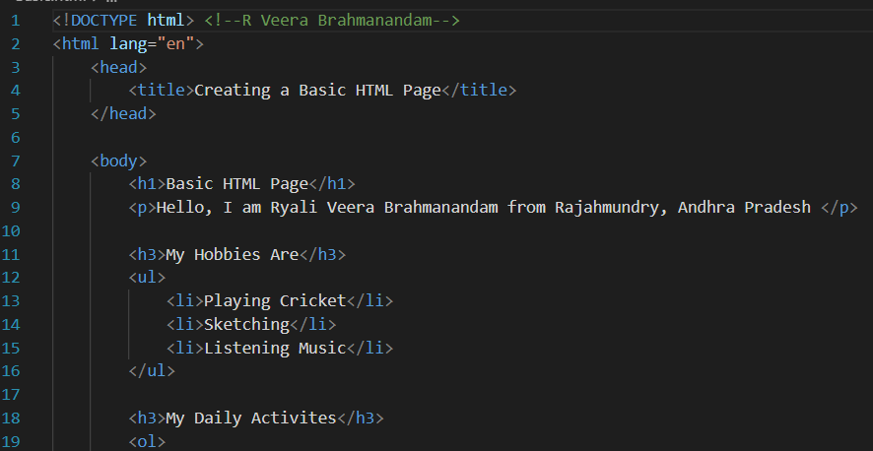

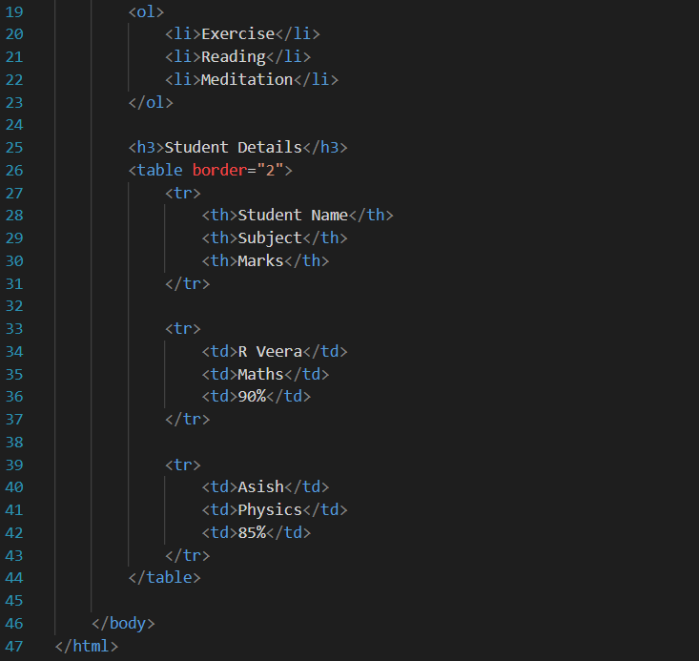
Output ScreenShot:
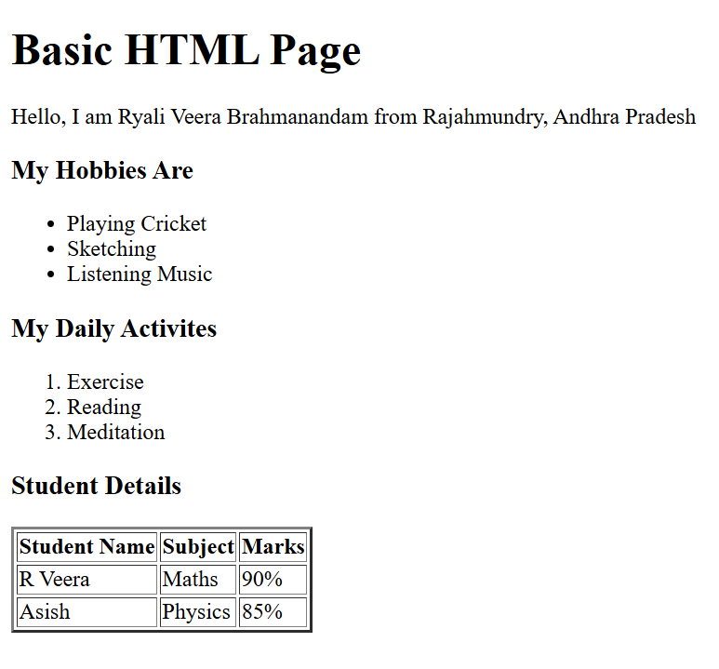
Code Explanation:
- This Basic HTML page starts by telling the browser that this is an HTML page, so that the browser will understand the how to read the file.
- And the language is set to English and helps the browser to know the page content language.
- The title is given as “Creating a Basic HTML Page”, which will be appears on the browser web.
- The main heading “Basic HTML Page” will be displayed for the top of the webpage
- The paragraph tag includes the Introduction by your name, and your hometown.
- After this a sub heading has been mentions with Hobbies and they have been listed in the unordered way by using the <ul> tag.
- Another section with My Daily Activities and shows your regular routines in an ordered list.
- The student’s details section displays academic information in a table format.
- The table has some headings for student name, subject and marks, followed by rows showing details of the two students clearly.
Problem 2:
Restaurant Menu Webpage (Level-1)
A small restaurant wants a basic menu webpage to display their offerings online before moving to a full website. Requirements:
Create an HTML page that displays: Restaurant Name (Heading), About the Restaurant (Paragraph), Menu Categories (Unordered List), Price List (Table), Table Structure, Item Name, Category, Price (₹)
Paneer Butter Masala, Main Course, 220
Veg Biryani, Main Course, 180
Masala Dosa, Breakfast, 90
Cold Coffee, Beverages, 120
Complete Code:
<!DOCTYPE html>
<html lang="en">
<head>
<meta charset="UTF-8">
<meta name="viewport" content="width=device-width, initial-scale=1.0">
<title> Restaurant Menu Webpage</title>
</head>
<body>
<h1>Eat and Play Restaurant</h1>
<p>Restaurant serve delicious food in a welcoming. They are perfect for casual hangouts for special celebrations </p>
<h2>Menu Categories</h2>
<ul>
<li>Breakfast</li>
<li>Main Course</li>
<li>Beverages</li>
</ul>
<h2 title="Price_List">Menu Price List</h2>
<table border="1">
<tr>
<th>Item Name</th>
<th>category</th>
<th>Price (₹)</th>
</tr>
<tr>
<td>Paneer Butter Masala</td>
<td>Main Course</td>
<td>220</td>
</tr>
<tr>
<td>Veg Biryani</td>
<td>Main Course</td>
<td>180</td>
</tr>
<tr>
<td>Masala Dosa</td>
<td>Breakfast</td>
<td>90</td>
</tr>
<tr>
<td>Cold Coffee</td>
<td>Beverage</td>
<td>120</td>
</tr>
</table>
</body>
</html>
Code ScreenShot:
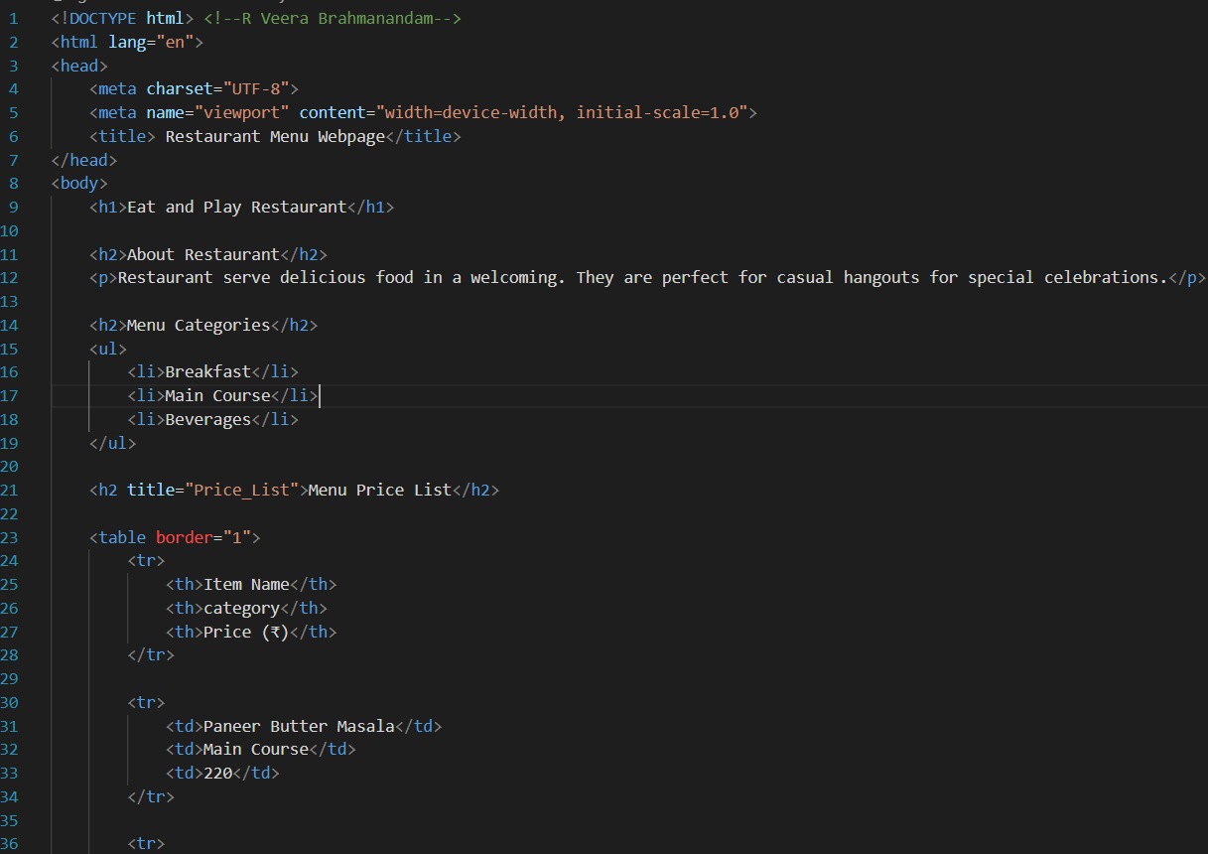
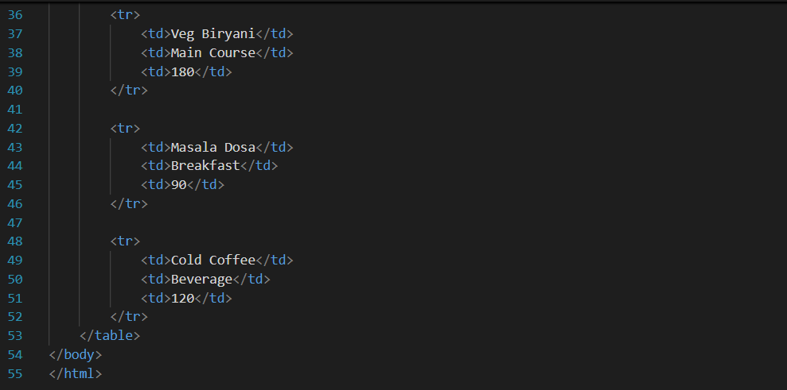

4. Output Screenshot:
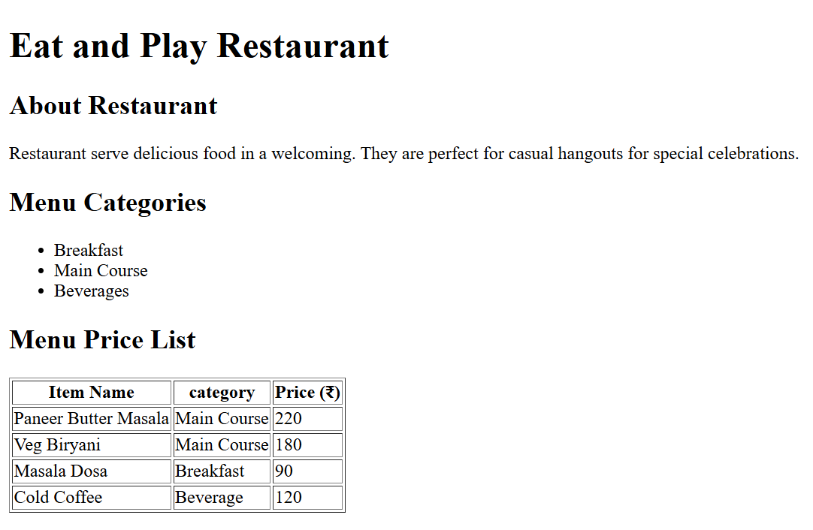
Code Explanation:
- The code creates a basic HTML webpage and it sets the page language by lang=”en”
- The restaurant name “Eat and Play Restaurant” is shown as the main heading of the page.
- After main heading there will be a short note About the Restaurant section and explains the type of the food.
- The Menu Categories sections are lists different food types like Breakfast, main course and beverages.
- A table displays the menu items with their category and price of the food and making the menu easy to read and understand to the customers.
Problem 3:
Personal Grocery Checklist (Level-1)
Scenario: You are building a simple webpage for personal use to plan your weekly grocery shopping. The page should clearly show priority items and optional items, so it’s easy to decide what to buy first.
Requirements: Create an HTML webpage that includes, A page title, Weekly Grocery Checklist,
A main heading displaying the same title. An Ordered List showing high-priority grocery items, such as: Rice, Milk, Vegetables, Cooking Oil
An Unordered List showing optional or non-essential items, such as: Snacks, Ice cream, Soft drinks
Complete Code:
<!DOCTYPE html>
<html>
<head>
<title>Grocery Items</title>
</head>
<body>
<h1>Personal Grocery Checklist </h1>
<h2>high-priority grocery items</h2>
<ol>
<li>Rice</li>
<li>Milk</li>
<li>Vegetables</li>
<li>Cooking Oil</li>
</ol>
<h2>Optional Grocery Items</h2>
<ul>
<li>Snacks</li>
<li>Ice cream</li>
<li>Soft Drinks</li>
</ul>
</body>
</html>
Code Screenshot:
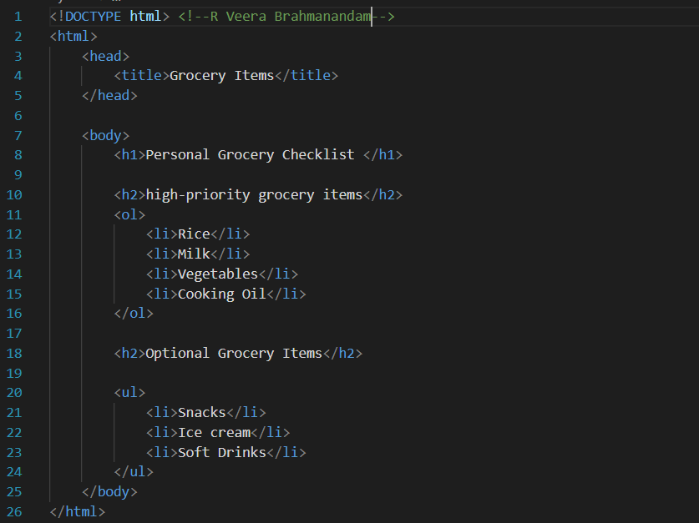
Output Screenshot:
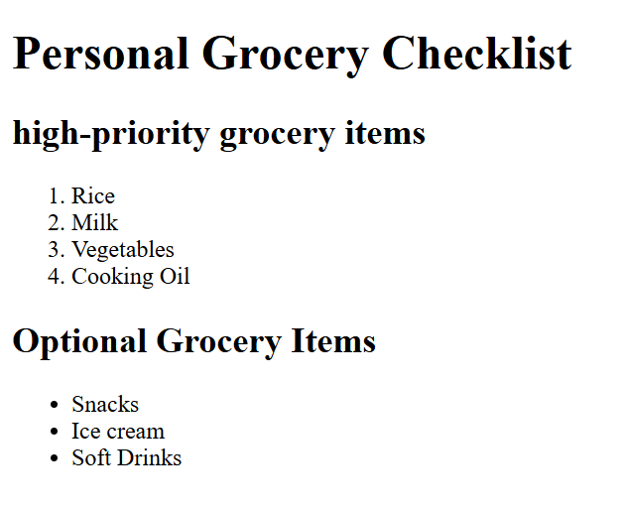
Code Explanation:
- This code creates a very simple HTML webpages for listing the grocery items.
- The page is titled as the “Grocery Items”, which will be visible on the browser tab.
- The main heading as “Personal Grocery Checklist” tells that the page is about.
- The “high priority grocery items” section shows important grocery need to be but at first when visited.
- Important items are shown in the numbered lists.
- “Optional Grocery Items” sections are displayed in the bullet points, and shows that items are not urgent.
Problem 4:
4: Employee Onboarding Page (Level-2)
Scenario: A company wants a basic onboarding page for new employees that HR can later style using CSS. Requirements: Use Semantic HTML: <header> → Company name & welcome message, <section> → Employee details, <article> → Company policies, <footer> → Contact information
Content Structure: Employee Information (Table), Employee ID, Name, Department, Joining Date
Company Policies (Ordered List): Working hours, Leave policy, Code of conduct
Facilities Provided (Unordered List): Laptop, Internet access, Training materials
Complete Code:
<!DOCTYPE html>
<html lang="en">
<head>
<meta charset="UTF-8">
<meta name="viewport" content="width=device-width, initial-scale=1.0">
<title>Employee Onboarding Page</title>
</head>
<body>
<h1>Basic Onboarding Page</h1>
<header>
<h1>Expert Technologies</h1>
<p>Welcome to the Employee Onboarding Portal</p>
</header>
<main>
<section>
<h2>Employee Information</h2>
<table border="1">
<tr>
<th>Employee ID</th>
<th>Name</th>
<th>Department</th>
<th>Joining Date</th>
</tr>
<tr>
<td>EMP101</td>
<td>R Veera</td>
<td>Testing</td>
<td>20-02-2026</td>
</tr>
<tr>
<td>EMP102</td>
<td>Asish</td>
<td>Software Engineer</td>
<td>02-03-2026</td>
</tr>
</table>
</section>
<article>
<h2>Company Policies</h2>
<ol>
<li>Working hours are from 9:30 to 6:30</li>
<li>Leave policy</li>
<li>Code of conduct</li>
</ol>
<h2>Facilities Provided</h2>
<ul>
<li>Laptop</li>
<li>Internet Access</li>
<li>Training Materials</li>
</ul>
</article>
</main>
<footer>
<h2>HR Contact Information</h2>
<p>Name: Prabakar R</p>
<p>Email: prabakarHR@gmail.com</p>
<p>Phone: 9876543210</p>
</footer>
</body>
</html>
Code Screenshot:
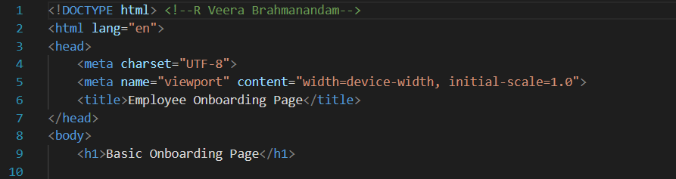
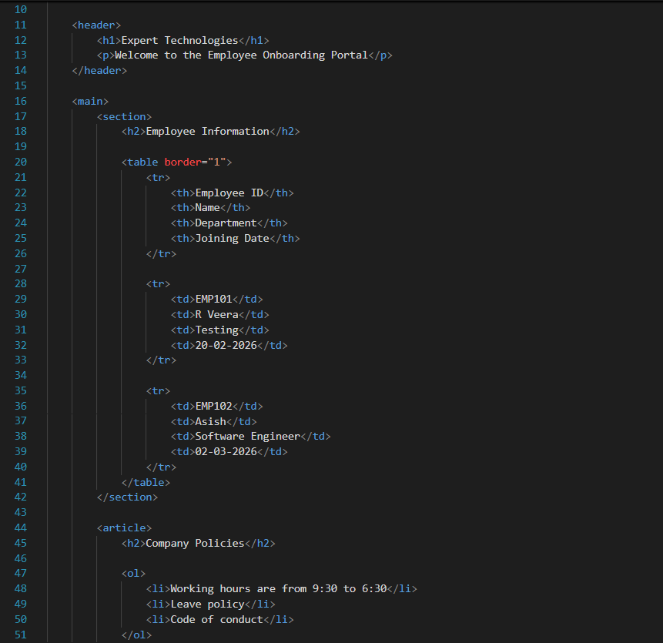
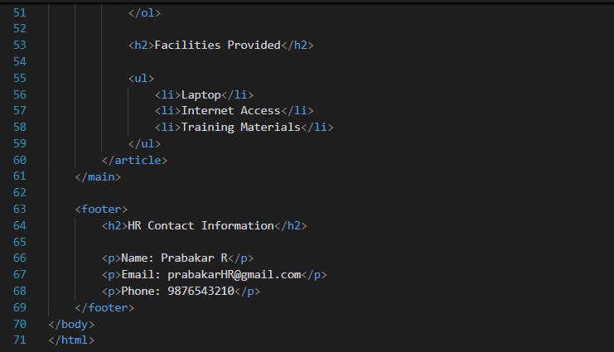
Output Screenshot:
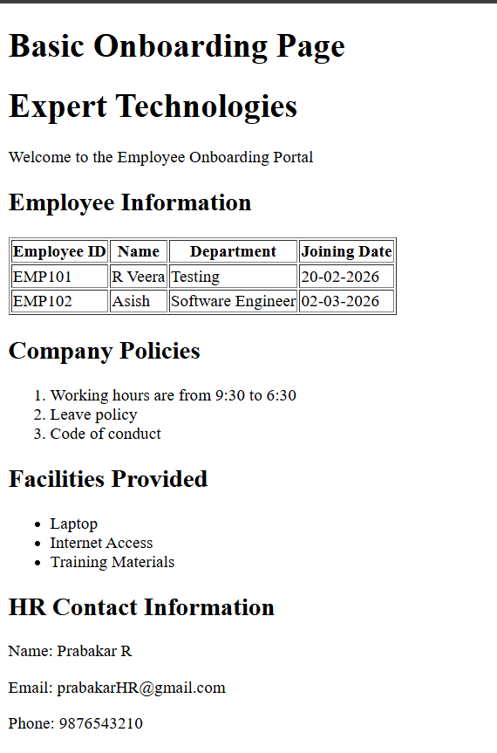
Code Explanation:
- The code creates a basic HTML webpage for the employee onboarding details.
- This page is titled as “Employee Onboarding Page” which will be displayed on the browser tab.
- The main heading is “Basic Onboarding Page” tells the purpose of the webpage.
- The header section shows the company name as “Expert Technologies” and a note as a Welcoming the new employees.
- The employee information displays as employee ID, name, department, and joining date
- After this it displays the company policies and it is a list some important rules of their company.
- The facilities section shows the what will the company provides to the employees like laptop and all.
- By the end of the footer section their will be details of the HR with the information name, emails, and contact details.
Problem 5:
5: College Department Information Page (Level-2)
Scenario: A college wants to create a basic informational webpage for one of its departments (e.g., Computer Science, Information Technology).
The page will be used by students and parents to understand faculty details, subjects offered, and the weekly timetable before the site is enhanced with CSS and backend features.
Requirements: Create an HTML webpage that includes the following sections:
- Header: Department Name, College Name
- Section 1: Faculty Details: Display faculty information in a table with columns: Faculty Name, Designation, Subject Handled
- Section 2: Subjects Offered: Display the list of subjects using an unordered list
- Section 3: Weekly Timetable: Display timetable details in a table with columns: Day, Subject, Time Slot
- Footer: College address, Contact information
Complete Code:
<!DOCTYPE html>
<html lang="en">
<head>
<meta charset="UTF-8">
<meta name="viewport" content="width=device-width, initial-scale=1.0">
<title>Department Information</title>
</head>
<body>
<header>
<h1>Computer Science and Engineering</h1>
<h2>Sathybama University</h2>
</header>
<section>
<h3>Faculty Details</h3>
<table border="1">
<tr>
<th>Faculty Name</th>
<th>Destination</th>
<th>Subject handled</th>
</tr>
<tr>
<td>Dr. Ramesh Kumar</td>
<td>Professor</td>
<td>Data Structures</td>
</tr>
<tr>
<td>Dr. Sunil Yadav</td>
<td>Assistant Professor</td>
<td>Operating Systems</td>
</tr>
<tr>
<td>Mr. Arjun Das</td>
<td>Lecturer</td>
<td>Java Programming</td>
</tr>
</table>
</section>
<section>
<h3>Subjects Offered</h3>
<ul>
<li>Programming in Java</li>
<li>data Structures</li>
<li>database Management Systems</li>
</ul>
</section>
<section>
<h3>Weekly Timetable</h3>
<table border="1">
<tr>
<th>day</th>
<th>Subjects</th>
<th>Time Slots</th>
</tr>
<tr>
<td>Monday</td>
<td>Data Structures</td>
<td>9:00 AM - 10:00 Am</td>
</tr>
<tr>
<td>Tuesday</td>
<td>Programming in Java</td>
<td>10:00 AM - 11:00 AM</td>
</tr>
<tr>
<td>Wednesday</td>
<td>database Management Systems</td>
<td>11:00 AM - 12:00 PM</td>
</tr>
<tr>
<td>Thursday</td>
<td>Operating Systems</td>
<td>12:00 PM - 1:00 PM</td>
</tr>
<tr>
<td>Friday</td>
<td>C Programming</td>
<td>1:00 PM - 2:00 PM</td>
</tr>
</table>
</section>
<footer>
<hr>
<p><b>College Address:</b> Sathyabama University, Chennai, Tamilnadu</p>
<p><b>Contact: </b>9876543210 | <b>Email:</b> Sathyabama@gmail.com</p>
</footer>
</body>
</html>
Code Screenshot:
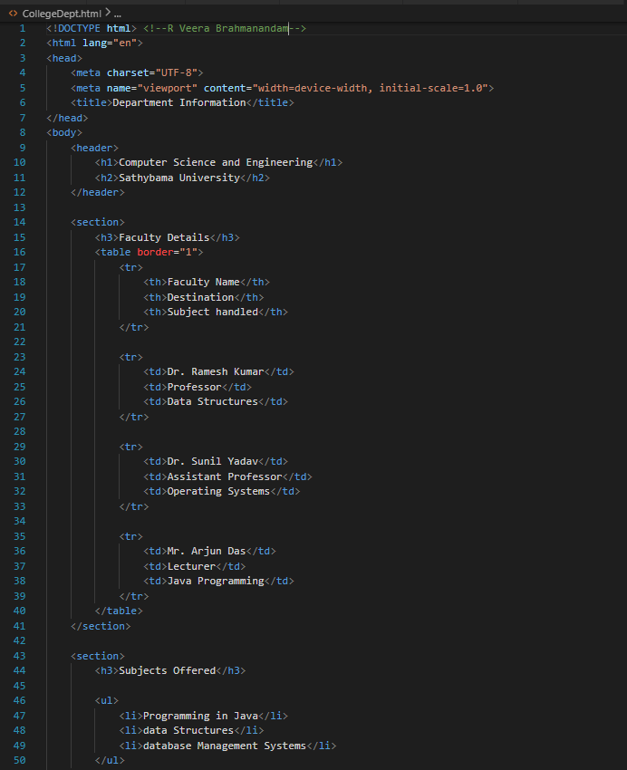

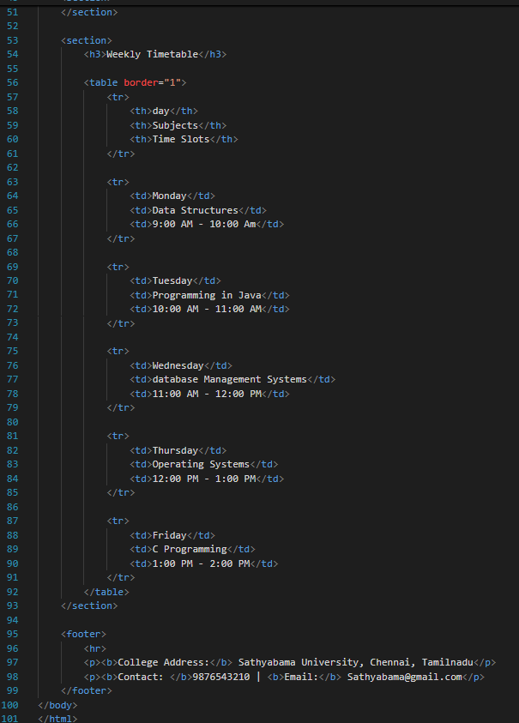

Output Screenshot:
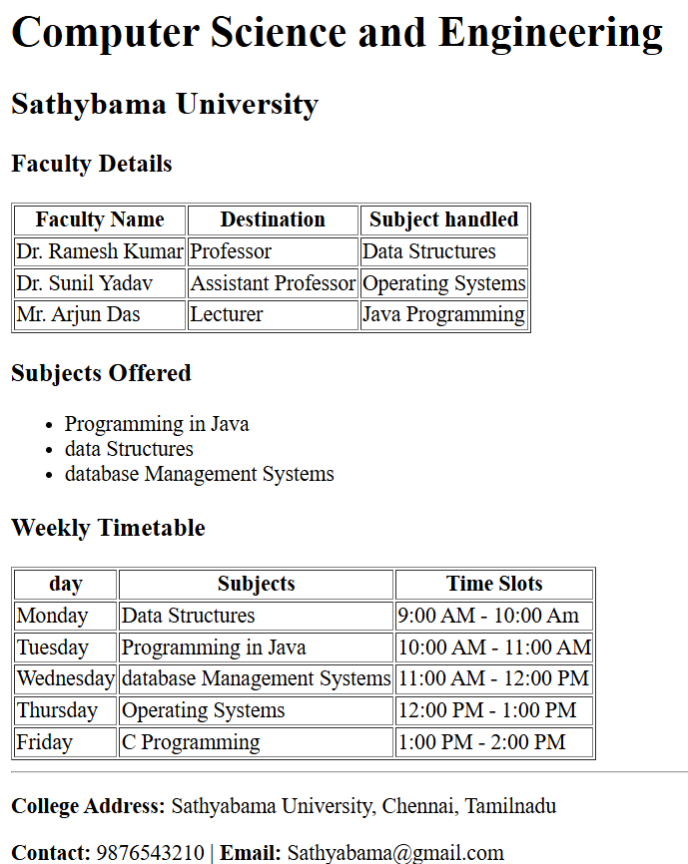
Code Explanation:
- This code shows the Department details of Computer Science and Engineering.
- The header displays the department name and the college name Sathyabama University.
- A table is used to show faculty names, their positions, and the subjects they teach.
- Another section lists the subjects offered and shows the weekly timetable with days and time slots.
- The footer gives the some information at the end of the page it consist of the college address and contact details for communication.
Problem 6:
6. To show image from external site and from your local folder create a html file
Complete code:
<!DOCTYPE html>
<html lang="en">
<head>
<meta charset="UTF-8">
<meta name="viewport" content="width=device-width, initial-scale=1.0">
<title>Image Task</title>
</head>
<body>
<h1>Displaying Images</h1>
<h3>Local folder image</h3>
<img src="Images/Varanasi MB.jpg" alt="MB" width="500" height="300">
<h3>Image from External Site </h3>
<img src="https://placehold.co/600x400/orange/white" alt="Image" width="500" height="300">
</body>
</html>
Code Screenshot:
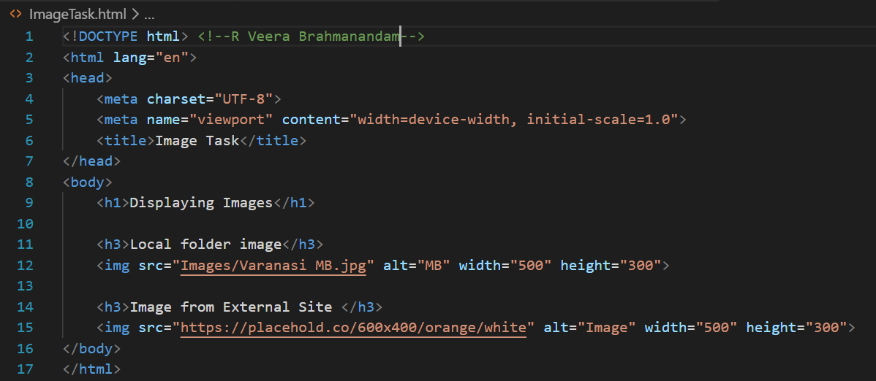
Output Screenshot:
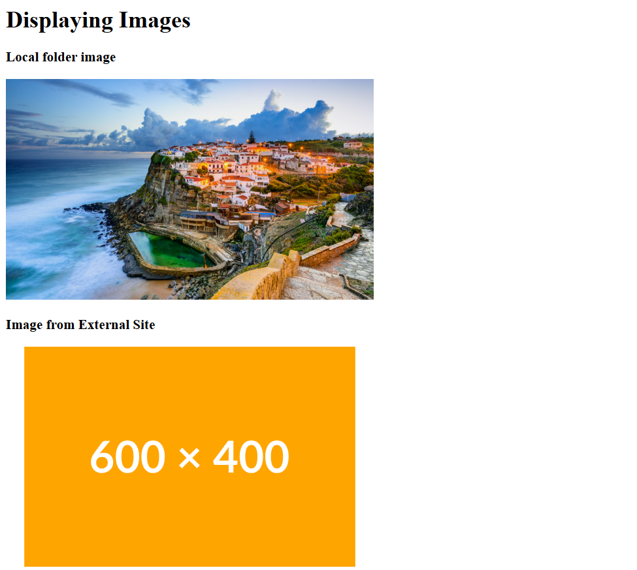

Code Explanation:
- This code creates the basic HTML webpage to show the external device image and local folder image.
- The header displays the title as” Image Task” on the browser tab.
- The main heading displays the “Displaying Images”
- The first image is loaded from the local folder named as “Images” using the image file “Nature.jpg”
- The second image is loaded from an external website using online image link.
- The alt text gives a description.

